**BASH Shell: Change The Color of Shell Prompt on Linux or UNIX**

You can change the color of your shell prompt to impress your friend or to make your own life quite easy while working at the command prompt. BASH shell is the default under Linux and Apple OS X. Your current prompt setting is stored in a shell variable called PS1. There are other variables too, like PS2, PS3 and PS4.  
  
Bash displays the primary prompt PS1 when it is ready to read a command, and the secondary prompt PS2 when it needs more input to complete a command. Bash allows these prompt strings to be customized by inserting a number of backslash-escaped special characters.

**Task: Display current BASH prompt (PS1)**

Use the echo command to display current BASH prompt:  
$ echo $PS1  
Sample outputs:

[\\u@\h \\W]\\$

Here is another output from my Debian based system:  
$ echo $PS1  
Sample outputs:

\[\e]0;\u@\h: \w\a\]${debian_chroot:+($debian_chroot)}\u@\h:\w\$

By default the command prompt is set to [\u@\h \W]\$. The backslash-escaped special characters are decoded as follows:

* **\u**: Display the current username .
* **\h**: Display the hostname
* **\W**: Print the base of current working directory.
* **\$**: Display # (indicates root user) if the effective UID is 0, otherwise display a $.

**Task: Modify current BASH prompt**

Before you modify settings save your old prompt using the following command:  
oldps1="$PS1"  
So if you messed up, you can switch back easily using the following syntax:  
PS1="$oldps1"  
Use the export command to setup a new shell prompt:  
$ export PS1="[\\u@\\H \\W \\@]\\$ "  
Sample outputs:

~~[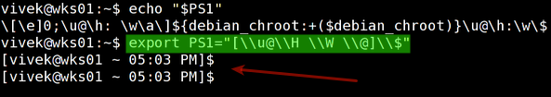](https://www.cyberciti.biz/faq/bash-shell-change-the-color-of-my-shell-prompt-under-linux-or-unix/change-bash-ps1-output/)~~Fig.01: New prompt in action

Where,

* **\H**: Display FQDN hostname.
* **\@**: Display current time in 12-hour am/pm format

**Task: Add colors to the prompt**

To add colors to the shell prompt use the following export command syntax:  
'\e[x;ym $PS1 \e[m'  
Where,

* \e[ : Start color scheme.
* x;y : Color pair to use (x;y)
* $PS1 : Your shell prompt variable.
* \e[m : Stop color scheme.

To set a red color prompt, type the following command:  
$ export PS1="\e[0;31m[\u@\h \W]\$ \e[m "  
Sample outputs:

~~[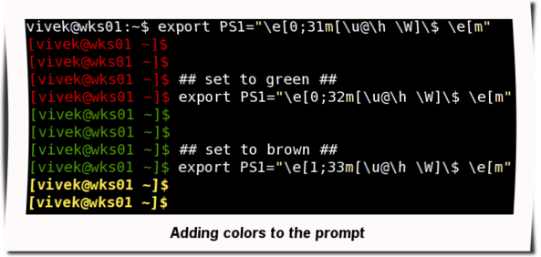](https://www.cyberciti.biz/faq/bash-shell-change-the-color-of-my-shell-prompt-under-linux-or-unix/bash-adding-colors-to-ps1-prompt/)~~Fig.02: Adding the colors to the prompt

**A LIST OF COLOR CODES**

|  |  |
| --- | --- |
| **Color** | **Code** |
| Black | 0;30 |
| Blue | 0;34 |
| Green | 0;32 |
| Cyan | 0;36 |
| Red | 0;31 |
| Purple | 0;35 |
| Brown | 0;33 |
| Blue | 0;34 |
| Green | 0;32 |
| Cyan | 0;36 |
| Red | 0;31 |
| Purple | 0;35 |
| Brown | 0;33 |

Note: You need to replace digit 0 with 1 to get light color version.

**Task: How do I make the prompt setting permanent?**

Your new shell prompt setting set by $PS1 is temporary i.e. when you logout setting will be lost. To have it set every time you login to your workstation add above export command to your $HOME/.bash_profile file or $HOME/.bashrc file.  
$ cd  
$ vi .bash_profile  
  
OR  
$ vi $HOME/.bashrc  
Append the following line:  
export PS1="\e[0;31m[\u@\h \W]\$ \e[m"  
Save and close the file.  
Add the following command in ~/.bashrc:

|  |
| --- |
| **export** PS1="\[\e[32m\][\[\e[m\]\[\e[31m\]\u\[\e[m\]\[\e[33m\]@\[\e[m\]\[\e[32m\]\h\[\e[m\]:\[\e[36m\]\w\[\e[m\]\[\e[32m\]]\[\e[m\]\[\e[32;47m\]\**\$**\[\e[m\] " |

You will get prompt as follows

**Say hello to tput command**

You can also use tput command to set terminal and modify the prompt settings. For example, to display RED color prompt using a tput:  
export PS1="\[$(tput setaf 1)\]\u@\h:\w $ \[$(tput sgr0)\]"

**A list of handy tput command line options**

* tput bold – Bold effect
* tput rev – Display inverse colors
* tput sgr0 – Reset everything
* tput setaf {CODE}– Set foreground color, see color {CODE} table below for more information.
* tput setab {CODE}– Set background color, see color {CODE} table below for more information.

**Various color codes for the tput command**

|  |  |
| --- | --- |
| **Color {code}** | **Color** |
| **0** | Black |
| **1** | Red |
| **2** | Green |
| **3** | Yellow |
| **4** | Blue |
| **5** | Magenta |
| **6** | Cyan |
| **7** | White |

**Example**

**export HOSTNAME="Cyberabc"**

**#PS1="[\[\033[1;36m\]\u\[\033[0m\]@ \[\033[1;35m\]\d \[\033[1;32m\]\w\[\033[0m\]=>]\$ "**

**export PS1="\[\e[32m\][\[\e[m\]\[\e[31m\]\u\[\e[m\]\[\e[33m\]@\[\e[m\]\[\e[32m\]\h\[\e[m\]:\[\e[36m\]\w\[\e[m\]\[\e[32m\]]\[\e[m\]\[\e[32;47m\]\\$\[\e[m\] "**